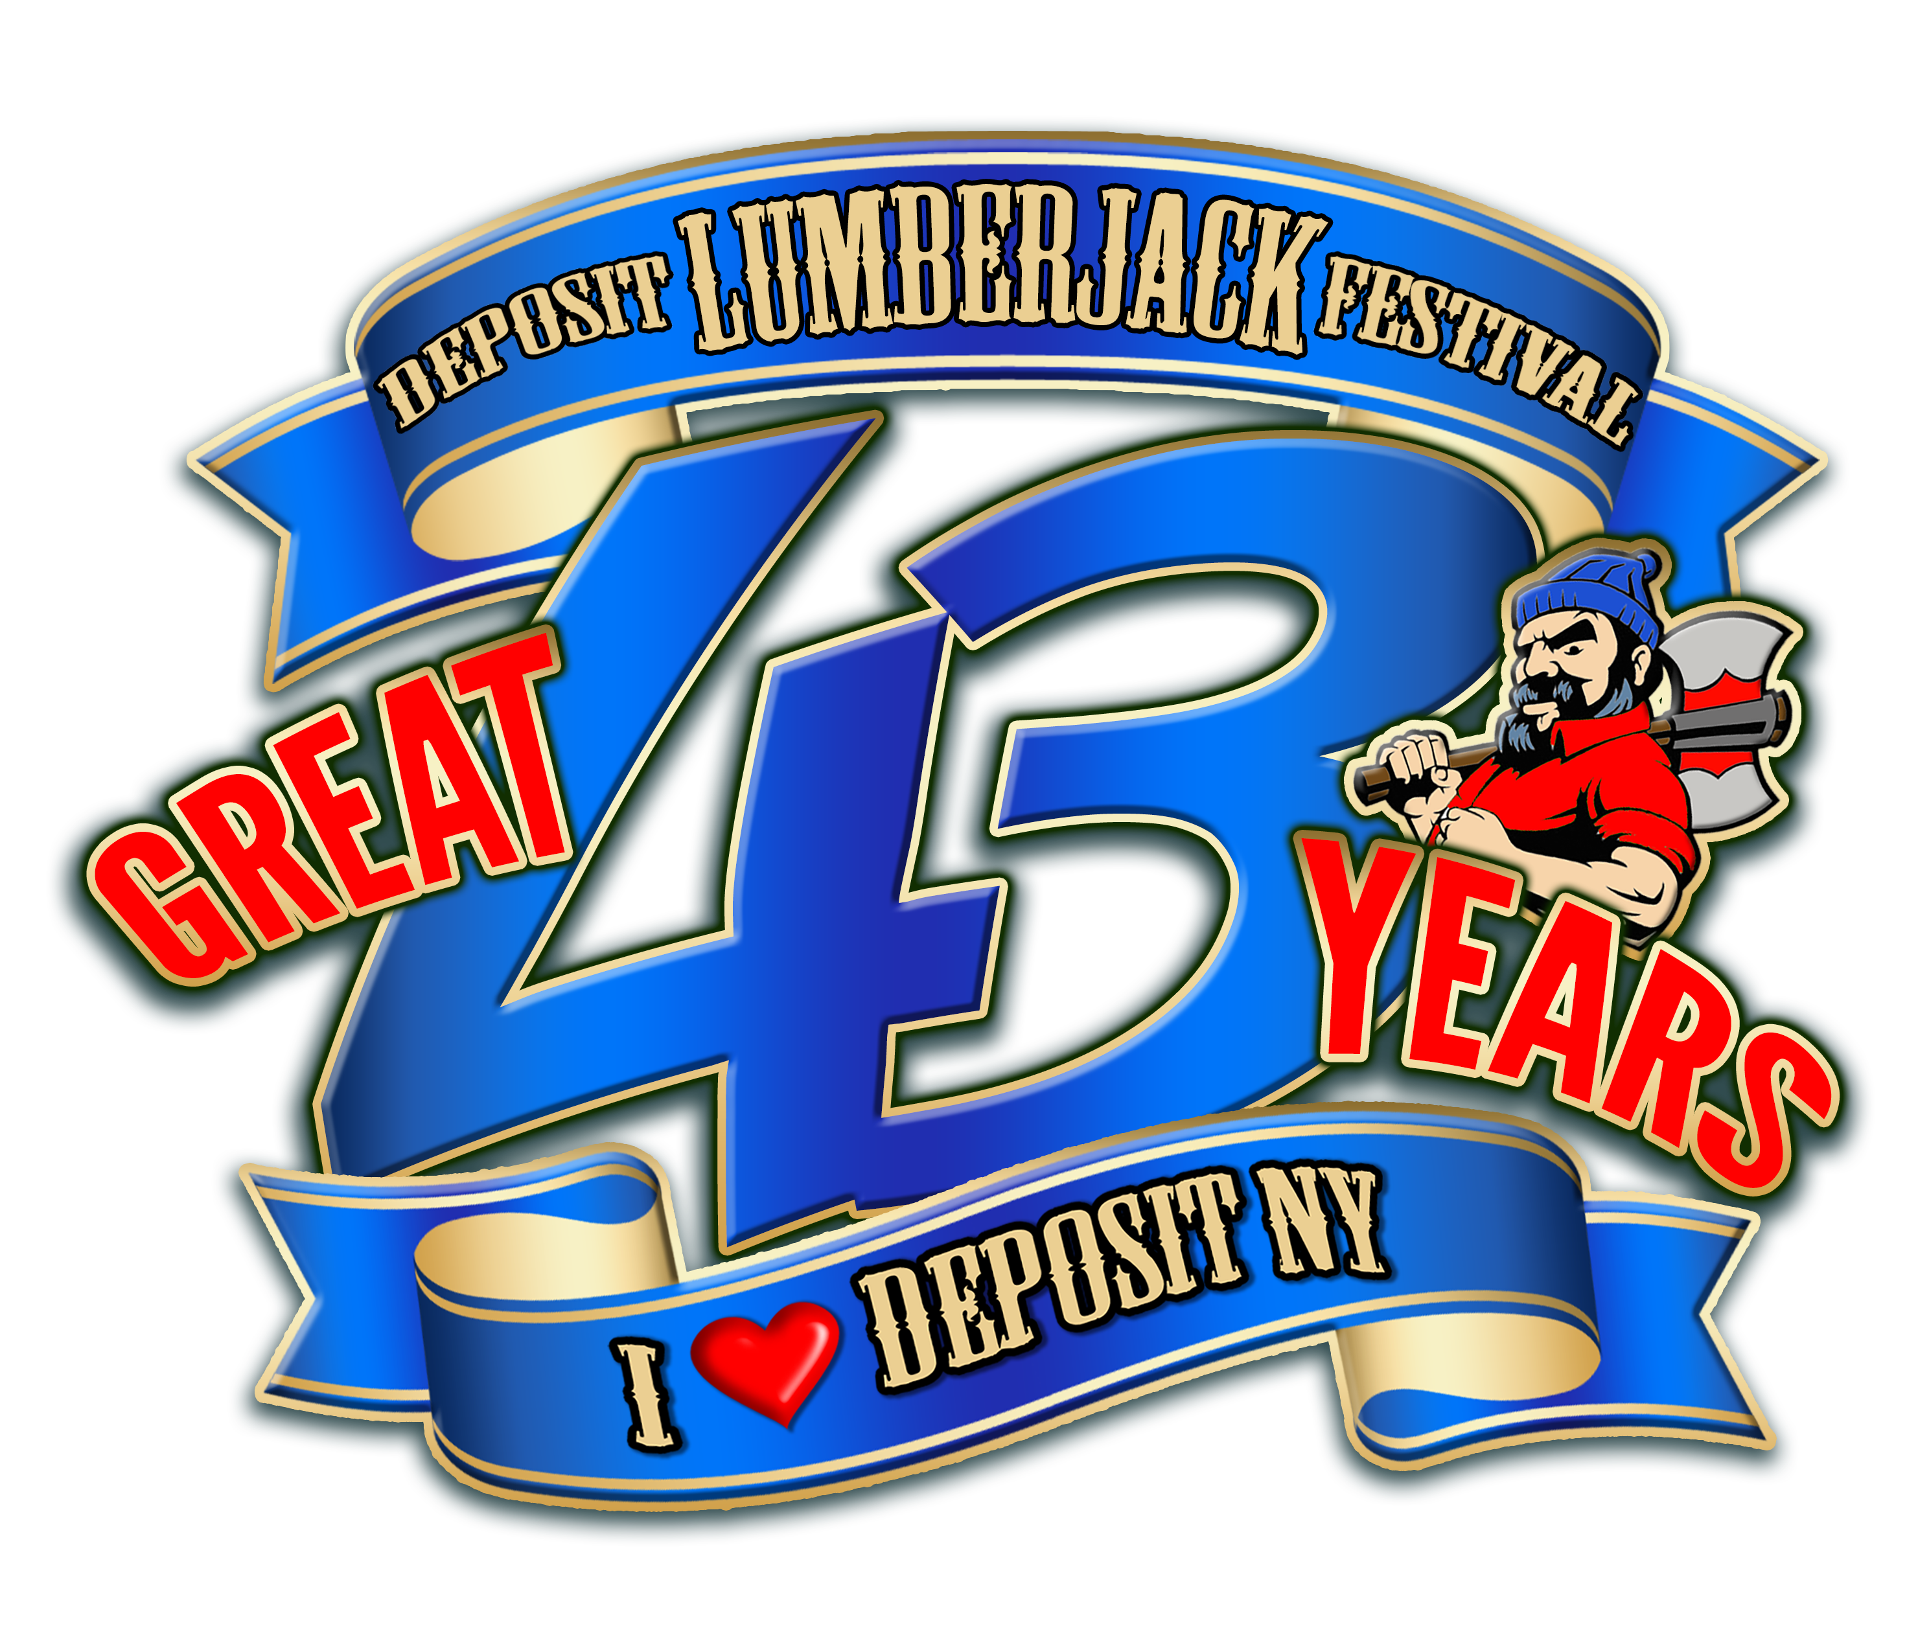

**43rd Deposit Lumberjack Festival**

PO Box 282, Deposit, NY 13754

*July 19th, 20th & 21st, 2019*

Dear Business Owner,

The Deposit Lumberjack Festival committee is in the process of designing the program book for our upcoming 43rd annual Deposit Lumberjack Festival, which will be celebrated July 19th, 20th, and 21st of this year.

We would like to offer you the opportunity to place an advertisement in this year’s business directory/program book which will be distributed throughout Deposit and neighboring communities, as well as be available on the field during the festival. As well as advertising in the book we offer sponsorship opportunities at the festival. With you sponsor ship you will also get free advertisements in the program.

This book has a four color front and back cover and is loaded full of local information and is used as a guide to the area as well as the festival:

**$250-$499.99 Sponsorship will receive 1/4 page ad free**

**$500- $999.99 Sponsorship will receive 1/2 page ad free**

**$1000 or more Sponsorship will receive a Full page ad free**

Please review the accompanying sheet of possible sponsorships (donations) and amounts available. You may indicate the level of sponsorship on the enclosed sponsor/donation order form.

Please indicate your desire for sponsorship and/or advertisement on that sheet, and send (along with your check) to:

**Deposit Lumberjack Festival, PO Box 282, Deposit, NY 13754**  no later than April 15, 2019, please

If you have any questions, please call Luke Tucker at 607-222-9412.

We appreciate your time and continued support of the Deposit Lumberjack Festival.

Thank You,

The Deposit Lumberjack Festival Committee

**43rdDeposit Lumberjack Festival**

PO Box 282, Deposit, NY 13754

*July 19th, 20th & 21st, 2019*

Sponsorship form:

Business Name: _______________________________________________________________

Contact Person: _______________________________________________________________

Phone number: ________________________________________________________________

Sponsorship amount: _________________________________________________________

Event Sponsoring: _____________________________________________________________

**Lumberjack Festival Advertising Rates:**

***Please check the size ad you wish to purchase:***

**_____ 1/8 page (business card) ad $40.00**

**_____ 1/4 page ad $75.00**

**_____ 1/2 page ad $135.00**

**_____ Full page ad $220.00**

We would prefer camera-ready copy or we can accept your ad electronically. If you need help composing your ad or need an email to send electronically, please contact Mike Zandt with that request at: [mikezandt@ezred.com](mailto:mikezandt@ezred.com)

Please include your check with your sponsorship/ad request. When sending camera-ready copy or a business card, please do NOT staple your check or anything to the copy.

Please send form, ad copy and check to:

**Deposit Lumberjack Festival, PO Box 282, Deposit, NY 13754** no later than April 15, 2019, please

**List of events to sponsor/co-sponsor for Deposit Lumberjack Festival 2016**

**42nd Deposit Lumberjack Festival**

PO Box 282, Deposit, NY 13754

*July 20th, 21st & 22nd, 2018*

Juggling act $500

Line dancing $200

Kids Games $150

Car Show $250

Pony Pulls $250

Horseshoe tournament $300

Tractor Pulls $300

Bike Give Away $400

Street Fair Entertainment $600

Friday Night Band $800

Saturday Night Bands $850/$750

Firemen’s Challenge $1000

Logging Challenge $4500

Family Day- Sunday $500

Fireworks $5,000

Animal Adventure— $450

Bainbridge old time band $250

Signs/Balloons around town $250

HOPSAW- Craft beer Saturday $700

Radio advertisements- $750

Bag Pipe band- $1500

Kids Bike decorating contest $225

Pirate kazoo band- $300

Raft Race- $500

Coloring contest $250

Program book printing $250

Yellow highlighted is a sponsored event.

Misc. Expenses— Electric, Insurance, bathroom attendant, Garbage clean up, Ect.

Parade- please contact us to discuss various entertainment units for the parade. Sponsorships vary according to units.

**Please contact Luke Tucker at 607-222- 9412 if you need further information.**

