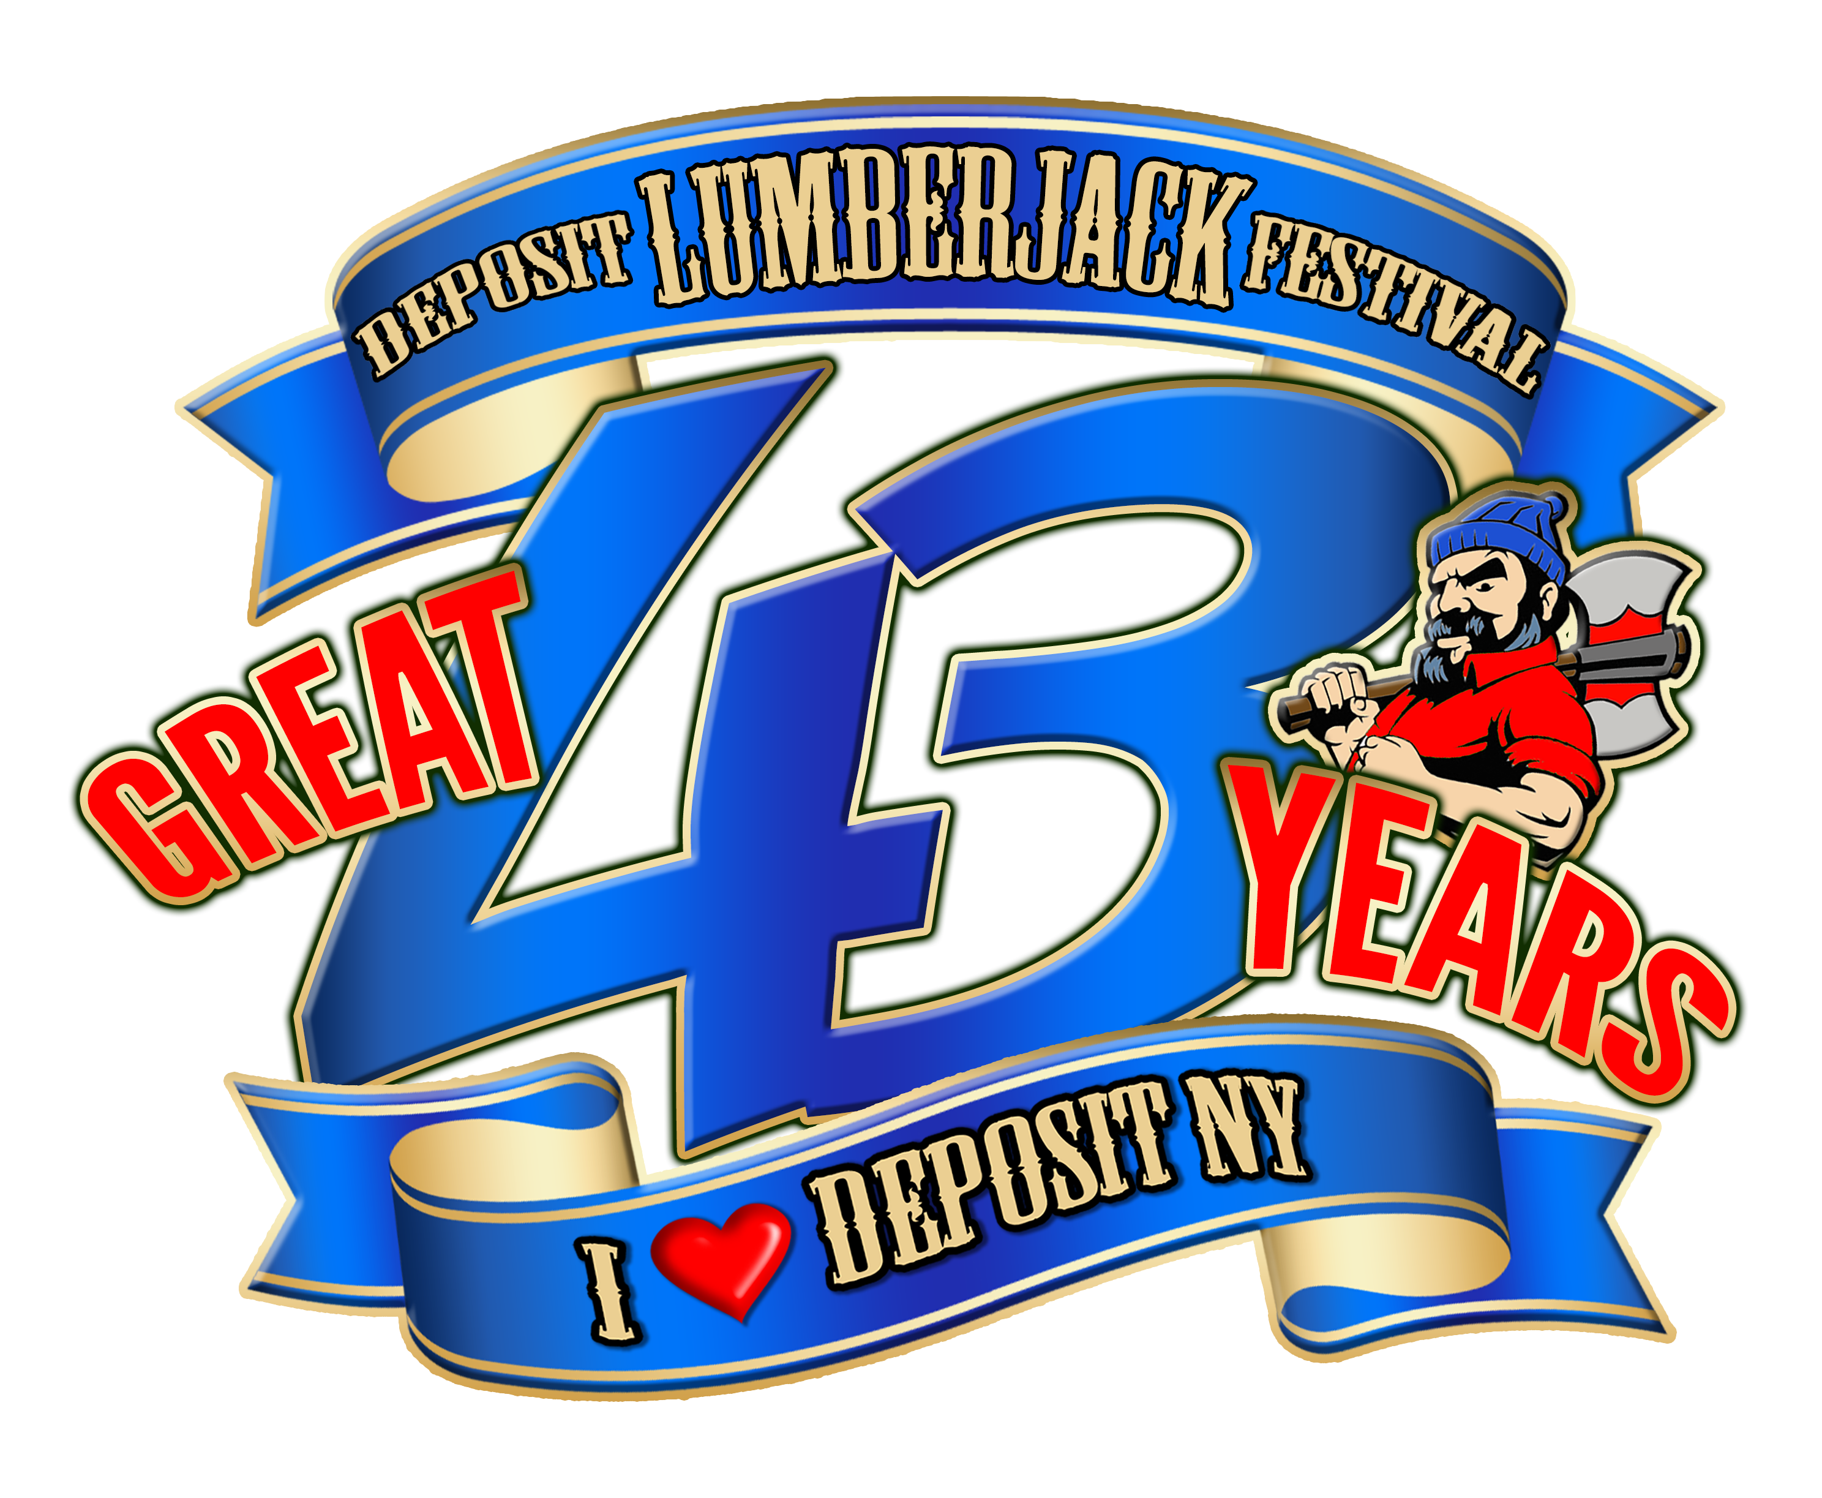
43rd Deposit Lumberjack Festival
PO Box 282, Deposit, NY 13754
July 19th, 20th & 21st, 2019

Dear Business Owner,
The Deposit Lumberjack Festival committee is in the process of designing the program book for our upcoming 43rd annual Deposit Lumberjack Festival, which will be celebrated July 19, 20 and 21st of this year.
We would like to offer you the opportunity to place an advertisement in this year’s business directory/program book which will be distributed throughout Deposit and neighboring communities, as well as be available on the field during the festival. In addition to advertising in the book we offer sponsorship opportunities at the festival. With you sponsorship you will also get free advertisements in the program.
This book has a four color front and back cover, is loaded with local information, and is used as a guide to the area as well as the festival.
Also please review the accompanying sheet of possible sponsorships (donations) and amounts available. You may indicate the level of sponsorship on the enclosed sponsor/donation order form. You will receive a free book advertisement with your sponsorship.
Please indicate your desire for sponsorship and/or advertisement on that sheet, and send (along with your check) to:
Deposit Lumberjack Festival, PO Box 282, Deposit, NY 13754 no later than April 15, 2019, please
If you have any questions, please call Luke Tucker at 607-222-9412.
We appreciate your time and continued support of the Deposit Lumberjack Festival.

Thank You,
The Deposit Lumberjack Festival Committee
43rd Deposit Lumberjack Festival
PO Box 282, Deposit, NY 13754
July 19th, 20th & 21st, 2019

List of events to sponsor/co-sponsor

Juggling act $500
Line dancing $250
Kids Games $200
Car Show $300
Pony Pulls $250
Horseshoe tournament $300
Tractor Pulls $300
Bike Give Away $400
Friday Night Band $700
Saturday Night Bands $850/$750
Firemen’s Challenge $1000
Logging Challenge $4500
Family Day- Sunday $500
Fireworks $5,000
Animal Adventure $550
Bainbridge Old Time Band $300
HOPSAW- Craft beer Saturday $1000
Bag Pipe band $1000
Kids Bike decorating contest $250
Pirate kazoo band- $300
Raft Race- $500
Coloring contest $250

More on Back
Program book printing $300
Sunday Band $400
Jack and Jill Lumberjack $2500
Misc. Expenses— Electric, Insurance, bathroom attendant, Garbage clean up, etc.
Parade- please contact us to discuss various entertainment units for the parade. Sponsorships vary according to units.
Please contact Luke Tucker at 607-222- 9412 if you need further information.

Deposit Lumberjack Festival Sponsorship form:
Business Name: _______________________________________________________________
Contact Person: _______________________________________________________________
Phone number: ________________________________________________________________
Sponsorship amount: _________________________________________________________
Event Sponsoring: _____________________________________________________________

